Tableau Analytics Dashboard Development Project
Final Project Report

Phase 1 – Initiation

Project Charter:
Project Name: Tableau Analytics Dashboard Development Project
Client: TechVision Analytics Inc.
Project Manager: Ravina & Team
Delivery Approach: Hybrid (Predictive + Agile)
Purpose:
To design and deploy an interactive Tableau dashboard that visualizes key business KPIs including sales performance, customer satisfaction, and product-level trends.
Business Need:
TechVision Analytics currently lacks a centralized dashboard for monitoring KPIs. This solution enables faster decision-making, reduces manual reporting, and enhances stakeholder visibility.
Objectives:
- Build a functional Tableau dashboard with minimum 3 KPI categories.
- Deliver iterative versions (V1, V2, V3) for feedback.
- Implement Agile execution through JIRA with full PM artifacts.
- Ensure 100% tested and validated data visuals.
Success Metrics:
- Dashboard approved by client.
- Filters fully functional.
- 95% accuracy in KPI calculations.
- Delivered within project timeline.
Constraints:
- Limited sample dataset.
- Three-weeks sprint timeline.
- Team availability restricted.
Assumptions:
- All tools (JIRA, Tableau) accessible.
- Stakeholders available for review.

2. Business Case:
Problem:
TechVision Analytics requires a KPI dashboard to monitor sales and customer behavior.
A centralized Tableau dashboard enables faster decision-making, reduces manual reporting, and improves business insights.
Impact:
- Manual reporting delays decisions.
- No centralized performance view.
Solution:
- A Tableau dashboard that consolidates sales, customer, and product insights.
Benefits:
  - 40–60% reduction in reporting effort.
  - Better decision-making visibility.
  - Improved stakeholder communication.
Cost Estimate :
Cost Category | Estimated Cost
Data Cleaning and Preparation | $800-$1000 (student project)
Tableau Dashboard Development | $3000 - $10000
Quality Testing & Documentation | $500 - $1500
Presentation & Reporting | $300 - $1000
Total Estimated Cost | $4600 - $13500

3. Stakeholder Register & Engagement Plan:
Stakeholder Register:
Stakeholder Name/Group | Role in Project | Interest/Expectations | Influence Level | Engagement Strategy
TechVision Analytics Inc. (Client Sponsor) | Project Sponsor | Wants a clean, professional Tableau dashboard showcasing KPIs for sales, product and store performance | High | Weekly updates, dashboard demos, feedback sessions
Project Manager (PM) | Leads project, manages JIRA, ensures PMBOK 7 alignment | Successful completion of project within timeline and scope | High | Daily coordination, sprint planning, status reports
Business Analyst (BA) | Gathers requirements, defines acceptance criteria | Clear KPIs and user requirements | Medium | Requirements workshops, review meetings
Data Lead (DL) | Cleans and validates dataset | Accurate and complete data for dashboard | High | Early data review, continuous communication
Dashboard Developer (DD) | Builds Tableau dashboard (v1–v3) | Clear technical requirements, stable dataset, timely feedback | High | Frequent check-ins, sprint reviews
Quality & Communication Lead (QL) | QA testing, documentation, stakeholder communication | Dashboard must meet quality standards | Medium | Testing cycles, issue logs, structured communication

Engagement Strategy:
Stakeholder | Information Needed | Method | Frequency | Owner
TechVision Sponsor | Project updates, dashboard progress | Email + Meetings | Weekly | PM
Instructor | PM artifacts, progress, risks | Reports + In-person review | Weekly | PM + QL
Project Team | Task assignments, sprint statuses | WhatsApp/Teams + JIRA | Daily | PM
BA | KPI requirements, acceptance criteria | Meetings | As needed | PM
DL | Data issues, validation status | Meetings/JIRA comments | Twice weekly | PM
DD | Priorities, feedback from reviews | Sprint review, standups | Daily | PM
QL | QA status, documentation tasks | Meetings + JIRA | Weekly | PM

Engagement Approach (Aligned with Hybrid Delivery)
Predictive Components
- Initial charter approval
- Project planning (WBS, Scope, timeline)
- Weekly scheduled updates to clients
Agile Components
- Sprint planning, sprint review, and sprint retrospective
- Daily stand-up recorded in JIRA
Continuous stakeholder feedback at each level of each iteration of the dashboard

Phase 2 – Planning

4. Scope Statement:
Project Scope Overview:
This project aims to design and deliver an interactive Tableau dashboard for TechVision Analytics using a sample dataset based on USA Adidas Sales. The dashboard will provide insights into sales performance, product trends, regional analysis, and key business KPIs. The project will be executed using a hybrid project management approach (Predictive + Agile) and managed through JIRA.
In-Scope:
  - Data cleaning
  - KPI calculations
  - Dashboard layout & filters
  - Testing
  - Documentation
Out-of-Scope:
  - Predictive modeling
  - Mobile dashboard version
Deliverables:
  - Tableau dashboard V1–V3
  - PMBOK documents
  - JIRA execution proof
  - Project closure report

5. Work Breakdown Structure (WBS):
TechVision Analytics – Tableau Dashboard Development Project
Dataset: Adidas USA Sales

1.Project Management or Initiation:
- 1.1 Develop Business Case & Project Charter
- 1.2 Create Stakeholder Register & Engagement Plan
- 1.3 Set Up JIRA Project (Epics, Stories, Roadmap)
2. Data Preparation or Planning:
- 2.1 Scope Statement
- 2.2 WBS
- 2.3 Communication Plan
- 2.4 Risk Register
- 2.5 Quality Plan
- 2.6 RACI
3. KPI Design & Dashboard Development or Execution:
3.1 Define KPI Requirements
3.1.1 Identify Business KPIs (Revenue, Category Sales, Store Performance)
    - Define Calculated Fields (Revenue, AOV, Peak Hours)
3.1.3Validate KPI Formulas with Dataset
3.2 Dashboard Prototype – Version 1
3.3 Dashboard Iteration – Version 2
3.4 Dashboard Final Version – Version 3
3.5 Apply Visual Design Standards (Color, Layout, Filters)
4. Quality Assurance Monitoring & Testing:
4.1 KPI Accuracy Testing
4.2 Dashboard Functionality Testing (Filters, Drilldowns, Tooltips)
4.3 Usability Review & Feedback Implementation
4.4 Stand-ups
4.5 Sprint Review
4.6 Burndown & Burnup
4.7 Issue Tracking
5.Delivery & Closure:
5.1 Final Dashboard
5.2 Lessons Learned
5.3 Feedback Summary
5.4 Final Presenation

6. Schedule Baseline (Roadmap Summary)
The project runs over two sprints:

Week 1: Initiation
Week 1-2 : Planning
Week 2 : Sprint 1: Data preparation + initial dashboard layout
Week 3 : Sprint 2: KPI cards + filters + final QA
Roadmap prepared in JIRA timeline view.
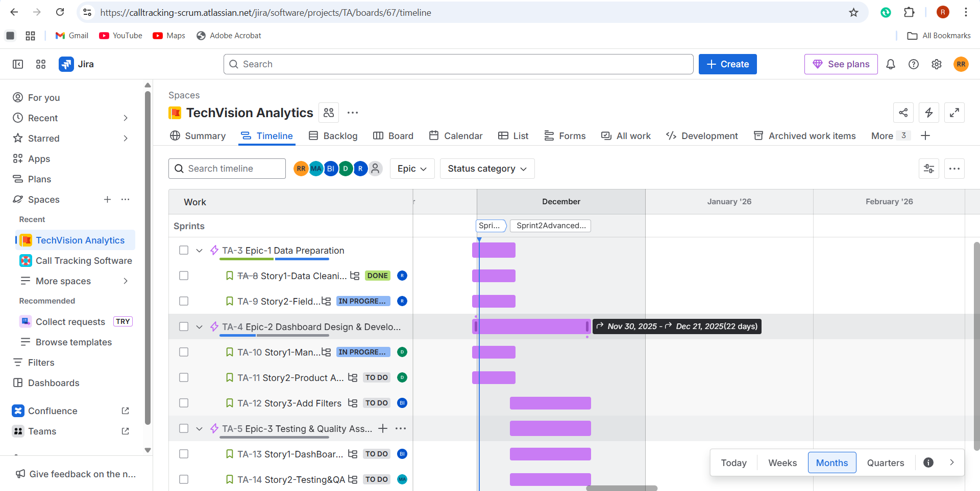

7. Risk Register:

Probability-Impact Matrix:

Risk | Prob | Impact | Score | Mitigation
Team member unavailability | Medium | High | 6 | Reassign roles early
Tableau issues | Low | High | 3 | Backup tools ready
Poor dataset quality | Low | High | 3 | Early data validation
Missed deadlines | Medium | Medium | 4 | PM enforces standups

8. Communication Management Plan
Stakeholder | Method | Frequency
Team Members | WhatsApp/Teams | Daily
PM → Sponsor | Email + report | Weekly
Sprint Review | Teams/JIRA | Bi-weekly
Final Presentation | In-class | End of Week 4

9. Quality Management Plan
Quality Criteria:
  - Accurate KPI metrics
  - Functional filters
  - Clean and intuitive UI

Quality Assurance:
  - Testing story executed
  - Bug identification (Issue TA-38)

10. RACI Matrix

PM – Accountable
BA – Responsible (requirements)
DL – Responsible (data)
DD – Responsible (visuals)
QL – Responsible (testing)
Activity | PM | BA | DL | DD | QL
Requirements | A | R | C | C | C
Data Cleaning | C | C | R | C | C
Dashboard Dev | C | C | C | R | C
Testing | C | C | C | C | R
Documentation | R | C | C | C | C
A = Accountable, R = Responsible, C = Consulted.

11. Tailoring Rationale
Hybrid model chosen due to:
  - Predictive for scope clarity
  - Agile for dashboard iteration cycles

Phase 3 – Execution & Monitoring

12. Execution Evidence (Sprint 1 & 2 Summary)
SPRINT BACKLOG:
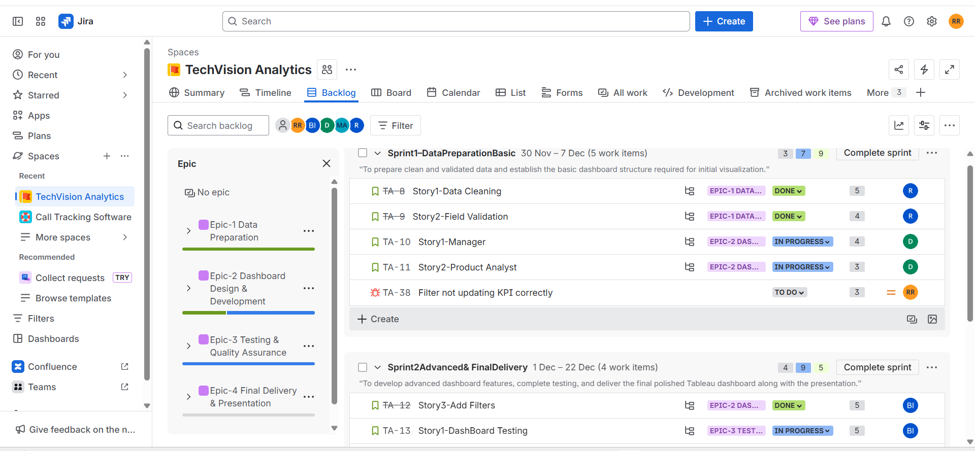
TRACKING PROGRESS:
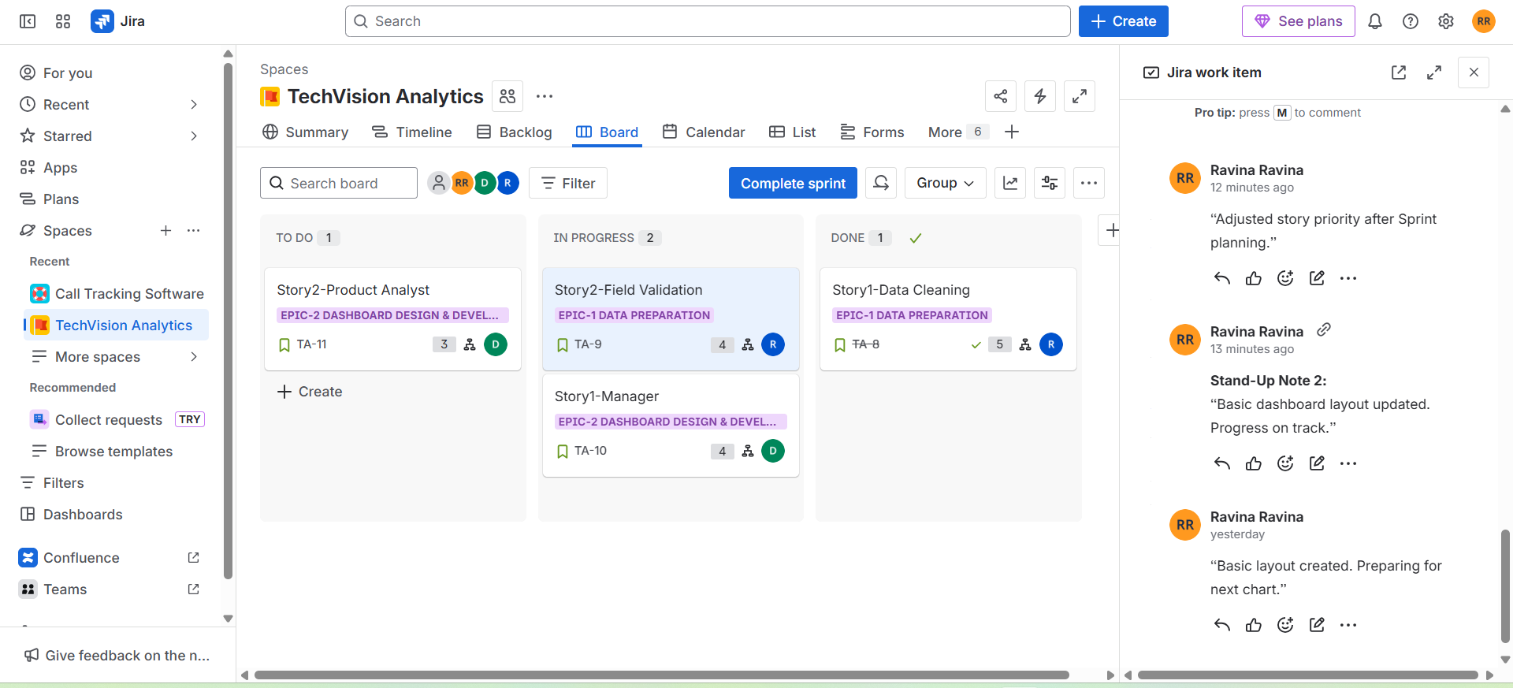

Sprint 1 Work:
  - Data cleaning
  - Field validation
  - Initial dashboard layout
  - Bug TA-38 logged
Stand-Up Notes:
  - “Worked on data cleaning today. No blockers.”
  - “Basic dashboard layout updated.”
Change Log:
  - Updated scope after bug TA-38.
  - Task priorities realigned.
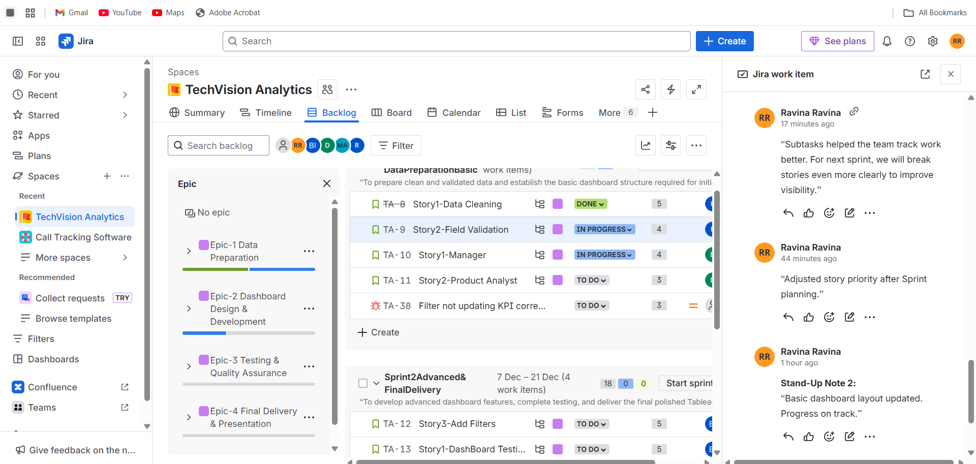
Retrospective:
- Sub-tasking improved clarity; refine further in Sprint 2.
Velocity:
Planned = 16 SP
Completed = 5 SP
Velocity = 5 SP

13. Monitoring & Control:
STATUS REPORT:
Status Report – Sprint 1
- Total Stories Planned: 16 Story Points
- Completed: 5 Story Points
- Remaining: 11 Story Points
- Bug Identified: TA-38 (Filter not updating KPI)
- Work in Progress: Data Cleaning, Dashboard Layout
- Risk identified and logged
- Team velocity for Sprint 1 = 5 SP

Burndown Chart:
Shows decreasing remaining work.
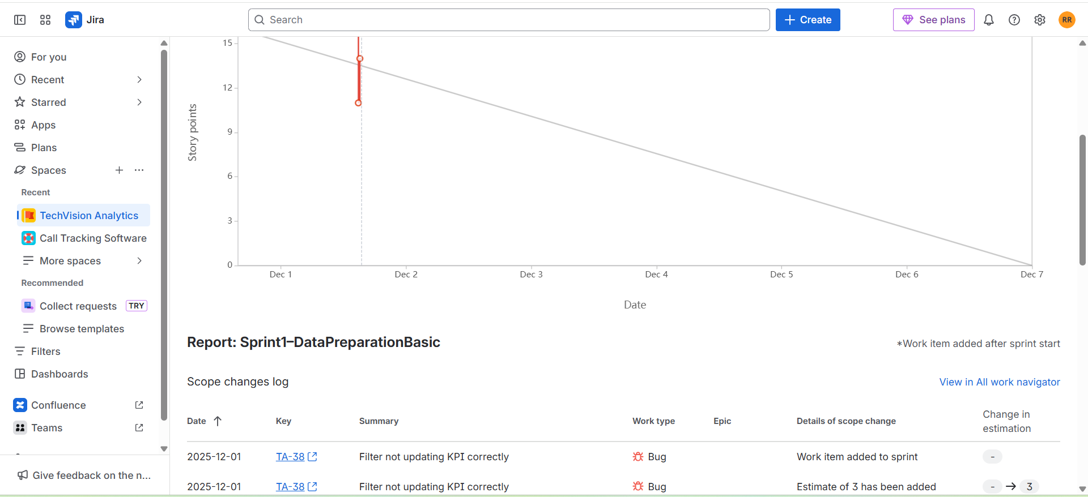

Issue Log:
Bug TA-38 added as risk update.
Issue ID: TA-38
Description: Filter not updating KPI correctly
Status: To Do
Sprint: Added to Sprint 1
Impact: Medium
Resolution Plan: To be fixed in Sprint 2
Risk Link: Functional failure risk
Burnup Chart:
Shows scope change + completed work.
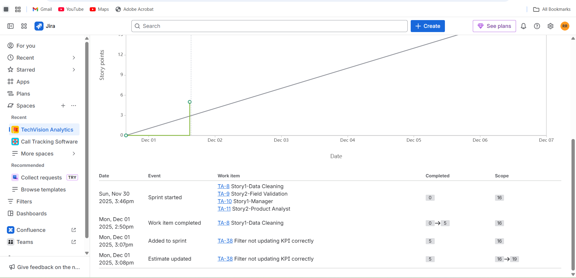

Dashboard prototype iterations (v1, v2, v3) with user feedback:
V1: Basic Version OR starting
SALES BY CATEGORY
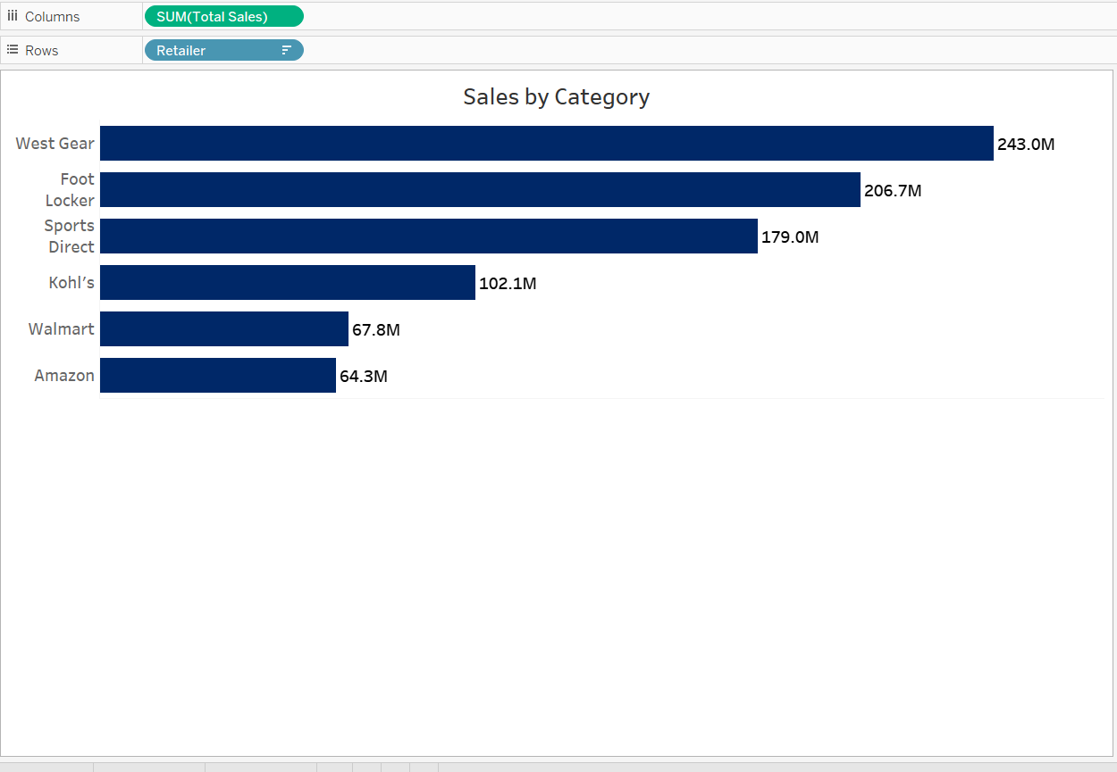
V2 : Improved Version
Add filters, better visuals, KPI cards.
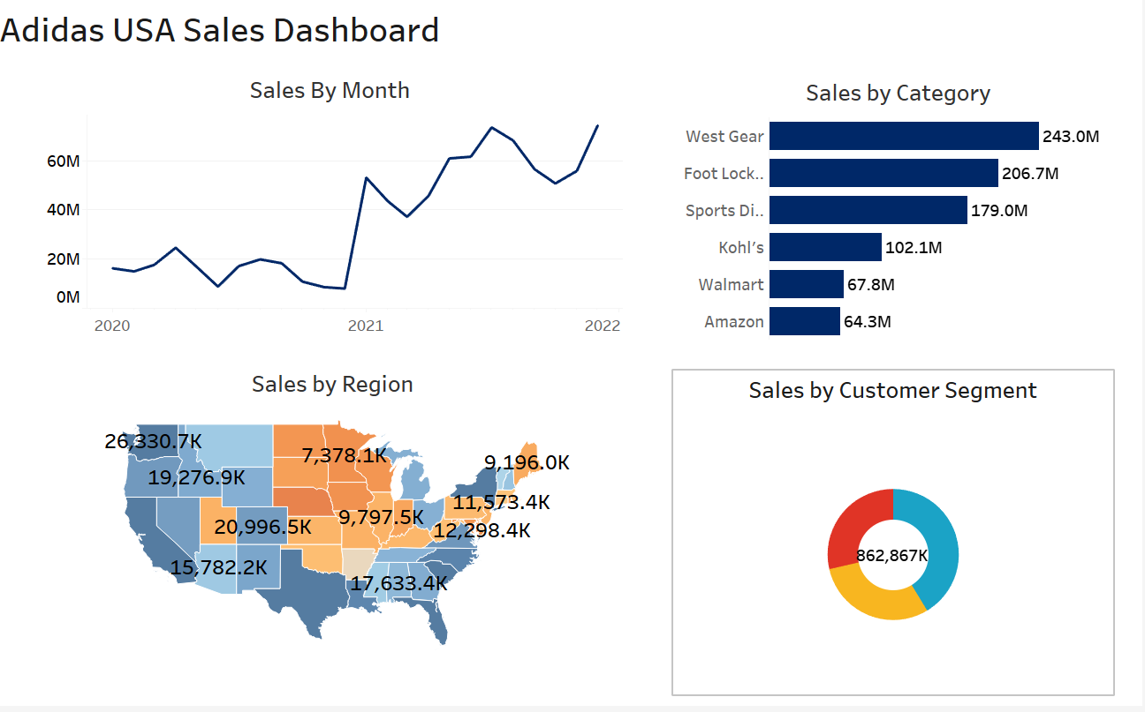
V3 : Final Polished Version
Interactions, formatting, colors, titles complete.
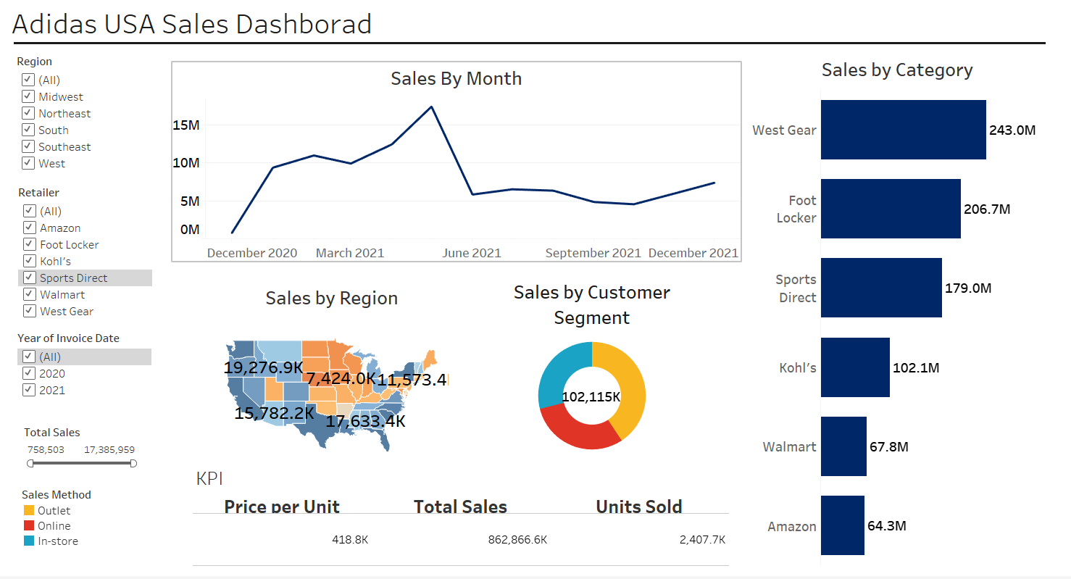
DATA DICTIONARY:
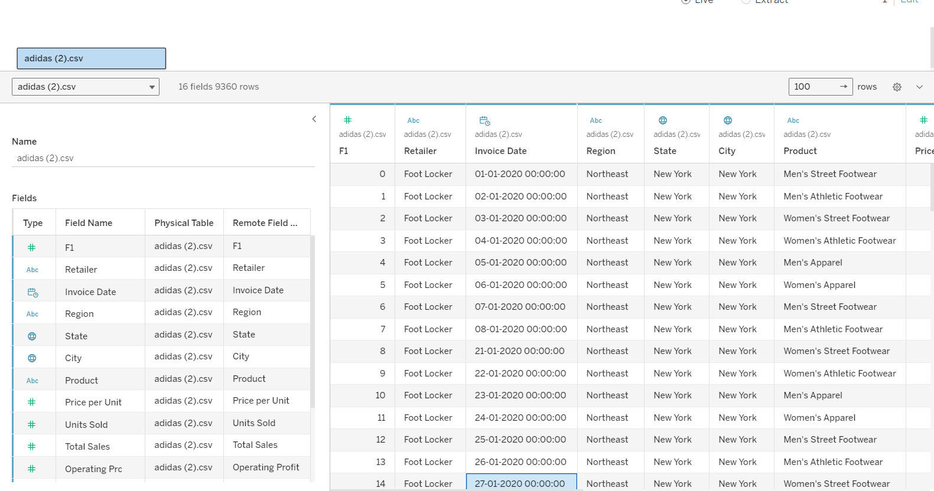

STATUS OVERVIEW OF JIRA DASHBOARD:
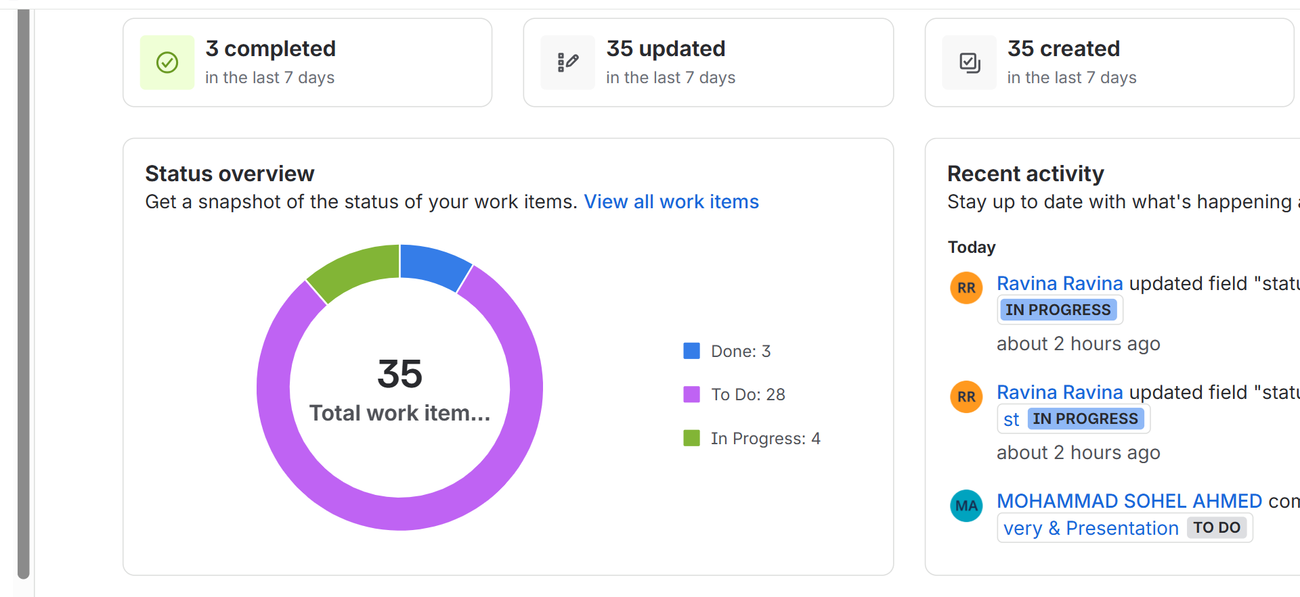
TEAM WORKLOAD AND EPICS PROGRESS:
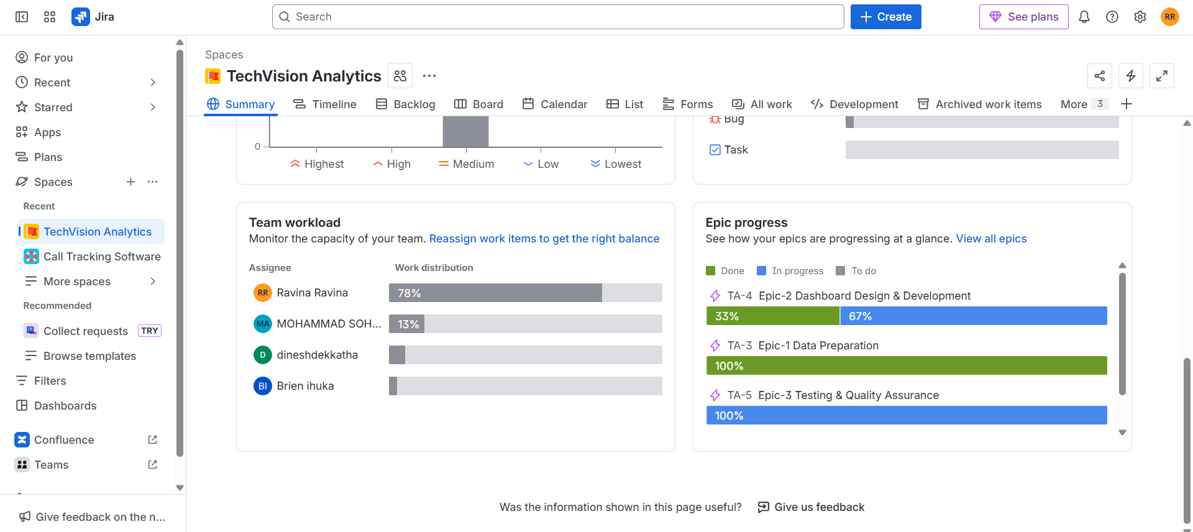

Phase 4 – Closure
Lessons Learned:
  - Hybrid model improves delivery flexibility
  - JIRA enhanced coordination
  - Early testing reduces rework
  - Clear roles improve productivity
Stakeholder Feedback:
  - Dashboard visually clear
  - KPIs easy to interpret
  - Filters helpful
  - Recommended deeper product breakdown
Final Conclusion:
The project successfully delivered a functional Tableau dashboard using a hybrid Predictive + Agile methodology.
JIRA supported planning, tracking, issue logging, and sprint execution.
The final dashboard helps TechVision Analytics make data-driven decisions efficiently.
Dashboard meets client needs and improves decision-making.

